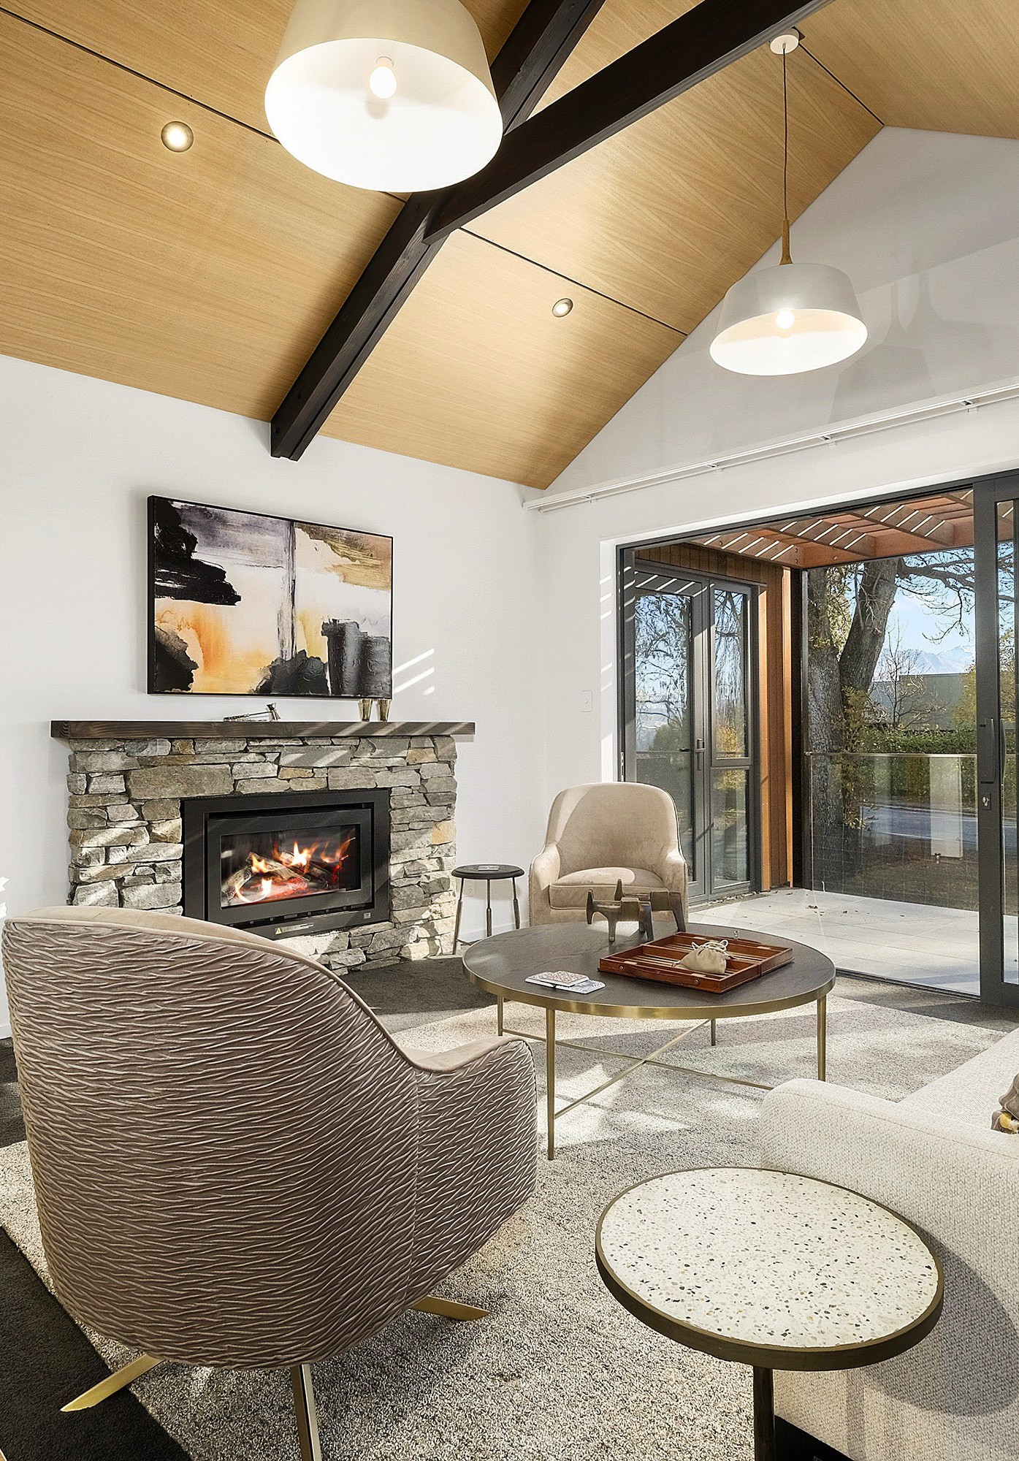

STAGE ONE
Purchase of Freehold Unit Title -
Unit | Price | Type | Status | Parking
D47 |  | McAlpine | Sold | Garage
D48 |  | McAlpine | Sold | Garage
D49 | $1,200,000 | McAlpine | For Sale | Garage
E50 | $1,200,000 | McAlpine | For Sale | Garage
F51 | $1,200,000 | McAlpine | For Sale | Garage
F52 |  | McAlpine | Sold | Garage
R1 |  | Ranfurly | Sold | Storage area
R2 |  | Ranfurly | Sold | Storage area
R3 |  | Ranfurly | Sold | Storage area
R4 |  | Ranfurly | Sold | Storage area
Other Units | Subject to Building Consent | New Plans being shared yet to be priced. | For Sale subject to discussion

*Prices are GST Inclusive. August 2021

